
AD600NA（R100）

Product Picture:
- Onboard Intel Alder Lake-U/-P series processors
- 2*DDR5 SO-DIMM, total max. 64GB
- Intel 2.5G network, single and dual network optional
- TPM2.0, 2*M.2 2280 SSD, M.2 WIFI
- 2*HDMI2.0, 1*DP, 2*Type-C (USB3.2+DP)
- DC 12-19V; Size: 120x120mm

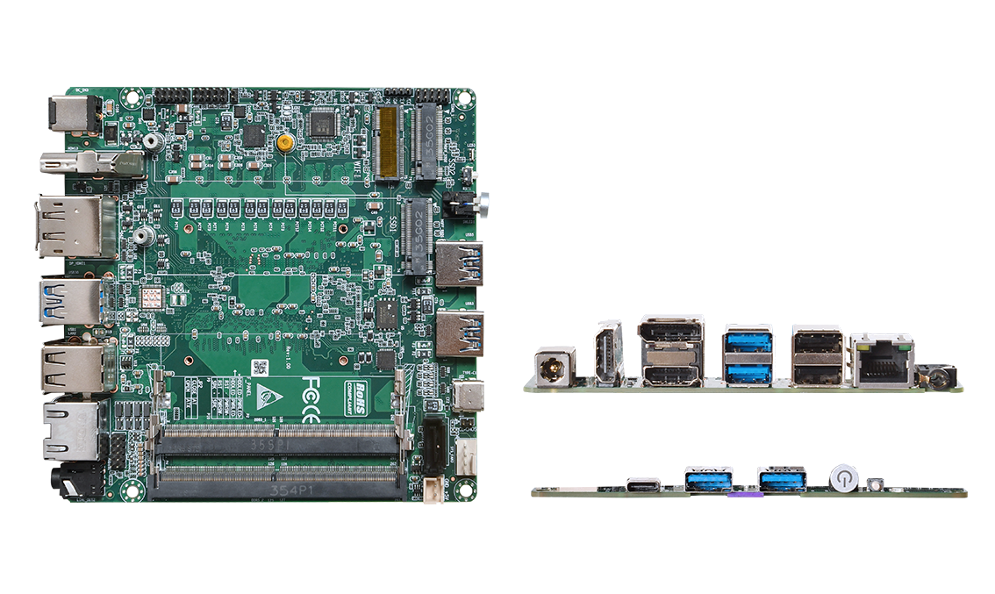

Product Specification
Processor System | Onboard Intel Alder Lake-U/-P series processor, TDP 28W
Processor System | EFI BIOS
Memory | 2*DDR5 SO-DIMM, up to 64GB total
Storage | 2*M.2 M-Key 2280(NVMe PCIe 4.0 x4/SATA3.0 protocol), order notes
Storage | 1*SATA3.0 interface, 2Pin 5V power supply
Display | 2*HDMI2.0 interface, support 4096x2160@60Hz
Display | 1*DP, support 7680x4320@60Hz
Display | Type-C interface, support DP 7680x4320@60Hz和USB3.2 Gen2
Board Side I/O Interface | Power on button, 2-in-1 audio jack, reset button, 4*USB3.0
Board Side I/O Interface | DC JACK, 2*HDMI, 1*DP, 1*Type-C
Board Side I/O Interface | Single and dual-network optional: single-network, rear I/O more than 2 * USB2.0
Expansion Interfaces/Features | External TPM2.0 optional, not available by default. Default is CPU built-in TPM2.0.
Expansion Interfaces/Features | 1*M.2 E-Key (PCIe+USB2.0 protocol, WIFI/BT module)
Expansion Interfaces/Features | 1*RS232/RS485 pin spacing 2.0mm
Expansion Interfaces/Features | 1*USB2.0 Pin, 2x5Pin, Pitch 2.0mm
Expansion Interfaces/Features | 1*4Pin PWM CPU FAN
Power Supply | DC 12-19V, 120W or above
Operating Environment | Operating Temperature: -20℃ ~ +60℃; Operating Humidity: 5% ~ 90
Operating Environment | Storage Temperature: -40℃ ~ +85℃; Storage Humidity: 5% ~ 90%
Operating System Support | Windows 10, Windows 11, Linux
Dimension | 120x120 mm
Net Weight | Approx. 130g without heat sink, 250g with heat sink
AD600NA（R100）

Product Size Unit：mm
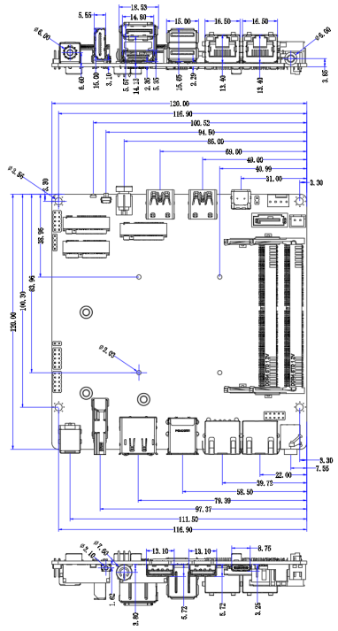

Ordering Information
Module | Optional items | Description of options
AD600NA | Onboard Intel Alder Lake-U/-P series processors | I3-1215U/I5-1235U/I7-1255U  I3-1220P/I5-1240P/I7-1260P
AD600NA | TPM2.0 | External TPM2.0 optional
AD600NA | Single and Dual Network Options | Single and dual network option
AD600NA | M.2 SSD protocol | PCIe4.0 x4 and SATA3.0 protocol optional

