
C-BOX-M3（R100）

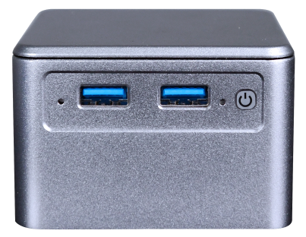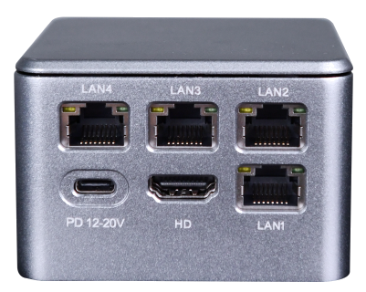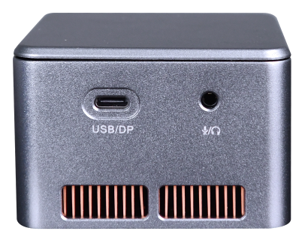

Product Specification
Processor | Onboard Intel Alder Lake-N Series Processor, N95/N300
Processor | EFI BIOS
Ram | Onboard LPDDR5x memory particles up to 16GB
Storage | 1*M.2 M-Key 2242, (NVMe PCIe3.0 x2/SATA3.0 protocol adaptive)
Expansion Slot | M.2 E-Key, (PCIe3.0 x1 + USB2.0 protocol), WIFI/BT
I/O port | 4*2.5G LAN (3*Intel 226-V, 1*RTL8156B)
I/O port | 1*HDMI2.0, 1*Type-C (USB+DP)
I/O port | 2*USB3.0, 2-in-1 audio jacks
I/O port | Power on button, 1 reset hole
I/O port | Type-C power input, support PD power supply
Power supply | DC 12-20V, 3A/PD
Working Environment | Operating Temperature: -20℃ ~ +60℃; Operating Humidity: 5% ~ 90
Working Environment | Storage Temperature: -40℃ ~ +85℃; Storage Humidity: 5% ~ 90
System | Windows 10, Windows 11, Linux
Size | 75x75x52mm
material | Metal body with plastic top cover
Weight | Packaging without adapter ~400g, with adapter ~450g

Order Information
Module | Optional | Optional description
C-BOX-M3 | Onboard Intel Alder Lake-N Series Processors | N95/N300
C-BOX-M3 | Onboard Memory Pellets | 8GB/16GB optional

