N-BOX-J2

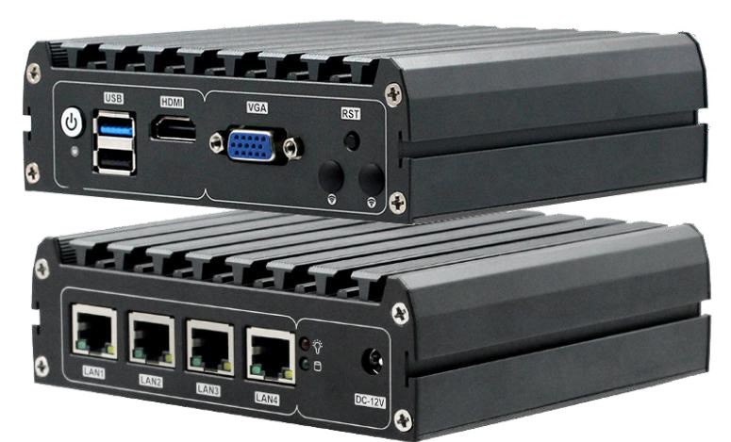
◆Onboard Intel Gemini Lake/Gemini Lake-R series CPU
◆DDR3 SODIMM 204 Socket Ram socket max support 8gb Ram
◆Onboard 32/64/128G EMMMC chipset (Optional)
◆Mini-PCIE socket，support wifi Module，combine with SIM card slot ，support 3G Module(only support USB singal equipment)
◆I/O rich Port,Including 2*USB Port/4*Intel I211 lan Card,1*HDMI,1*VGA display connector 1*RJ45 RS232 Port
◆12V DC Power supply
Specification

Mini PC | Model Name | N-BOX-J2
Mini PC | Color | Color
Mini PC | size | 134*126*45.3 mm
Mini PC | material | 6063
Motherboard | Chipset | Onboard Intel Gemini Lake/Gemini Lake-R series CPU
Motherboard | CPU | Support Gemini Lake-R series CPUJ4125/J4105)
Motherboard | Ram | Single channel DDR3 1066/1333/1600MHz，max support 8G
Motherboard | Graphics card | Intel HD Graphics
Motherboard | Expansion | 1*MINI-PCIE interface for loading wifi, 3G/4G modules (USB signal devices only)
Motherboard | Expansion | 1*MINI-SATA interface for loading SSD solid state drives
Motherboard | Expansion | 1* onboard EMMC 32/64/128G (optional)
Storage | HDD | 2.5inch laptop hard disk
Storage | SSD | SSD
Storage | EMMC | 32/64/128G（optional ）
Function | Display output | HDMI
Function | Internet Output | 4*Intel I225 Lan Port
Function | USB | 1*USB2.0、1*USB3.0
Function | Front I / O interface | 1* power switch (with indicator light), 1* reset button, 1*HDMI, 1*RJ45 interface RS232,  2*USB
Function | Rear I / O connector | 4*Intel I225 2.5G network ports, 1* power indicator, 1* hard disk indicator,  1*DC power supply interface
Function | Working temperature | -10~60℃
Function | Operating system | Windows10、linux
Function | Power supply | DC12-19V power supply

N-BOX-J2
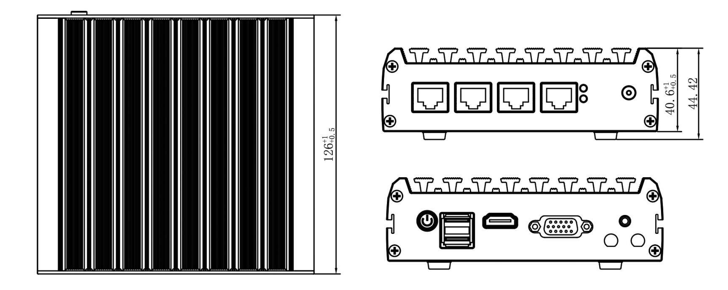
尺寸
单位：mm
+

Order information

model | optional | Description of options
GN41NA4L | Integrated Intel Gemini Lake/Gemini Lake-R series CPU | J4125/J5005/N4100/N5000
GN41NA4L | Onboard LPDDR4 memory chips | Optional 4GB/8GB
GN41NA4L | Onboard Storage Granule eMMC | Optional 32GB/64GB/128GB/256GB
GN41NA4L | RS485/RS232 optional | The chip on the motherboard is different
GN41NA4L | TPM2.0 | TPM2.0 optional

