N-BOX-J2

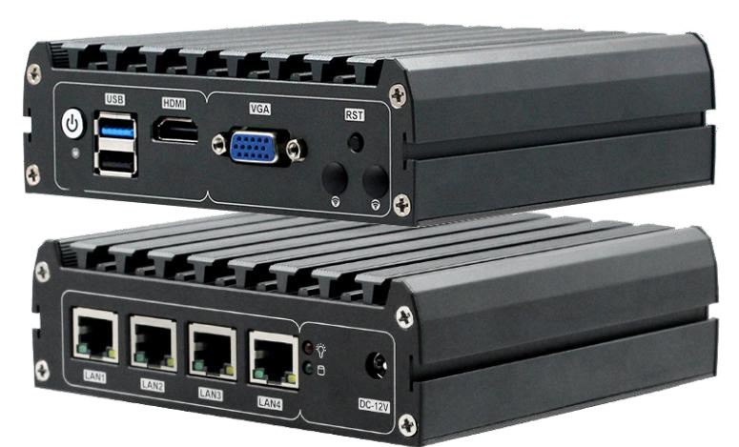
Compact and lightweight embedded design support for Intel Baytrail-D / I / M series processors;
DDR3 SODIMM 204 Socket Ram socket max support 8gb Ram
Onboard 32/64/128G EMMMC chipset (Optional)
Mini-PCIE socket，support wifi Module，combine with SIM card slot ，support 3G Module(only support USB singal equipment)
I/O rich Port,Including 2*USB Port/4*Intel I211 lan Card,1*HDMI,1*VGA display connector 1*RJ45 RS232 Port
The fanless design, no noise design, stable and efficient
12V DC Power supply
Specification

Mini PC | Model Name | N-BOX-J2
Mini PC | Color | Color
Mini PC | size | 134*126*45.3 mm
Mini PC | material | 6063
Motherboard | Chipset | Baytrail-I/D/M serial processor chipset
Motherboard | CPU | Support Baytrail-I/D/M serial CPU (J1900 J1800)
Motherboard | Ram | Single channel DDR3 1066/1333/1600MHz，max support 8G
Motherboard | Graphics card | Intel HD Graphics
Motherboard | Expansion | 1*MINI-PCIE interface for loading wifi, 3G/4G modules (USB signal devices only)
Motherboard | Expansion | 1*MINI-SATA interface for loading SSD solid state drives
Motherboard | Expansion | 1* onboard EMMC 32/64/128G (optional)
Storage | HDD | 2.5inch laptop hard disk
Storage | SSD | SSD
Storage | EMMC | 32/64/128G（optional ）
Function | Display output | HDMI
Function | Internet Output | 4*Intel I211 Lan Port
Function | USB | 1*USB2.0、1*USB3.0
Function | Front I / O interface | 1* power switch (with indicator light), 1* reset button, 1*HDMI, 1*RJ45 interface RS232,  2*USB
Function | Rear I / O connector | 4*Intel I211 high-performance Gigabit LAN, 1* power indicator, 1* hard disk indicator,  1*DC power supply interface
Function | Working temperature | -10~60℃
Function | Operating system | Windows7、Windows 8、Windows8.1 Windows10、linux
Function | Power supply | DC12-19V power supply

N-BOX-J2
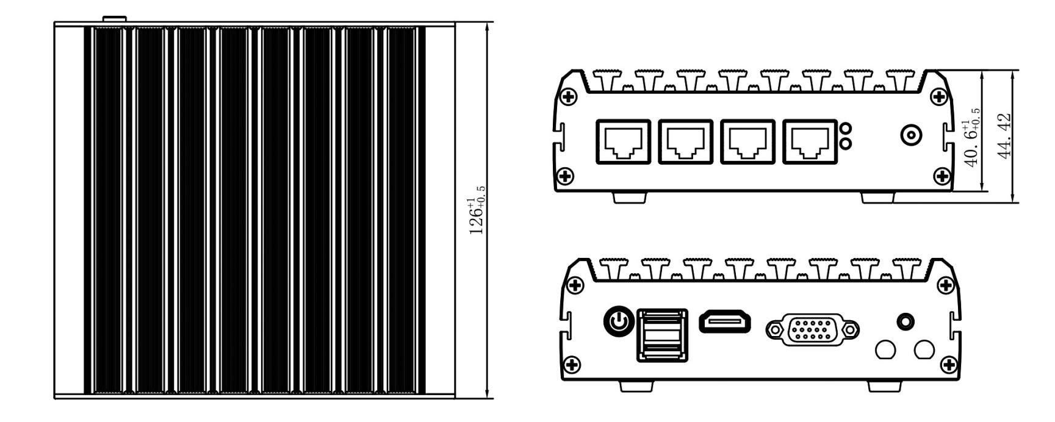
尺寸
单位：mm
+

Order information

BT19NA4L-J1900/E3845

BT19NA4L-J1800/n2806
Integrated Celeron Baytrail J1900 Quad core 2.0Ghz up to2.4Ghz
DDR3 SODIMM 204 Socket ram ,max to 8gb Embedded 32G/64/128G EMMC chipset （optional） Integrated celeron Baytrail J1800
CPU optional
description
Model
Dual core 1.6Ghz up to2.0Ghz
DDR3 SODIMM 204 Socket ram socket ,max tobe 8gb ram Embedded 32G/64/128G EMMC chipset (optional）

J1900 E3845(quad core）

J1800（dual core）

Packing list
1*Rack
1*CD driver
1*Mini PC

