
N-BOX-J7（R100）

Product features:
- Onboard Intel Alder Lake-N serial processor
- 1*DDR5 SO-DIMM，Max 16GB
- 4*2.5G network ports,choose POE
- TPM2.0，1*M.2 2280 SSD，MiniPCIe(WIFI/BT/4G/mSATA)
- HDMI2.0+DP，1*Type-C（USB+DP）
- DC 12V，36W；Size：134x126x41mm

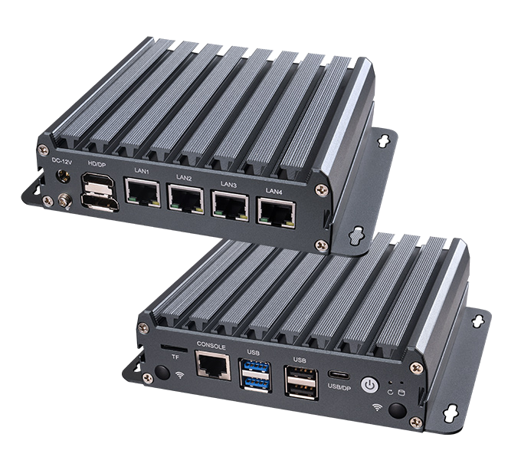

Product specification
Processor | Onboard Intel Alder Lake-N serial processor,TDP 15W
Processor | EFI BIOS
Ram | 1*DDR5 SO-DIMM，Max 16GB
Storage | 1*M.2 M-Key 2280(NVMe PCIe 4.0 x2/SATA3.0 protocol)
Storage | 1*SATA3.0 slot，2Pin 5V power
Display port | 1*HDMI2.0,support 4096x2160@60Hz
Display port | 1*DP,support 7680x4320@60Hz
Display port | Type-C,support DP 7680x4320@60Hz and USB3.2 Gen2
I/O interface | Power on button, reset button, 2*USB3.0, 2*USB2.0, TF card
I/O interface | DC JACK, HDMI+DP, Type-C
I/O interface | 4*2.5G LAN (3*Intel 226-V, 1*RTL8156B, optional POE), RJ45 console
Extended Interface/Function | External TPM2.0 is optional, not available by default. Default is CPU built-in TPM2.0.
Extended Interface/Function | 1*MiniPCIe (PCIe+USB2.0+SATA3.0 protocol, WIFI/BT/mSATA/4G module),Micro SIM card
Extended Interface/Function | 5*RS232/RS485 pin (hardware material selection), pitch 2.0mm; 8*GPIO
Extended Interface/Function | 1*4Pin PWM CPU FAN; 1*4Pin PWM SYS FAN
Power supply | DC 12V，36W Above
working environment | Operating Temperature: -20℃ ~ +60℃; Operating Humidity: 5% ~ 90
working environment | Storage Temperature: -40℃ ~ +85℃; Storage Humidity: 5% ~ 90%
operating system support | Windows10，Windows11，Linux
Size | 134x126x41 mm
Net weight | About 600g
N-BOX-J7（R100）

Product size unit：mm
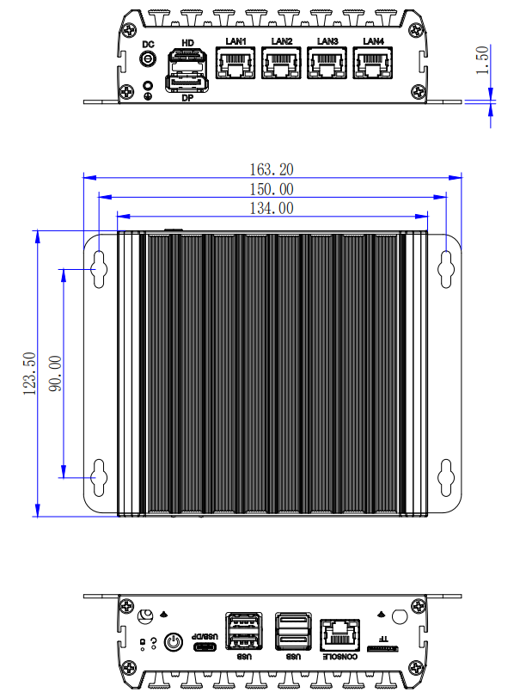

Ordering information
Model | Optional | Optional description
N-BOX-J7 | Onboard Intel Alder Lake-N Series Processor | N95/N100/N305
N-BOX-J7 | POE | POE optional
N-BOX-J7 | Type-C | Note required for order
N-BOX-J7 | Serial port pin optional (CONSOLE always has one) | Note required for order
N-BOX-J7 | RS232/RS485 Optional | RS232/RS485 selectable by hardware material
N-BOX-J7 | TPM2.0 | External TPM2.0 optional

