
N-BOX-S7(AD30NA4L) (R100)

Features
- Intel Alder Lake-N series processors;
- 1 x DDR5 SO-DIMM, maximum 16GB;
- 4 x 2.5G LAN, HDMI + DP + Type-C;
- M-Key 2280, Mini PCIe
- Power supply: DC12V
- Size: 123x220x80 mm
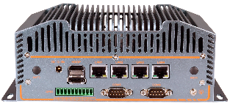

Product Specifications
Processor System | Intel Alder Lake-N series processors
Processor System | EFI BIOS
Memory | 1 x DDR5 SO-DIMM, max 16GB
Storage | 1 x M.2 M-Key 2280 (PCIe_x 2 protocol)
Display | 1 x HDMI2.0 interface, support 4K@60Hz
Display | 1 x DP1.4 interface, support 8K@60Hz
Display | 1 x Type-C interface, support 8K@60Hz
Front Panel Interface | 4 x USB; 3 x DB9 COM
Front Panel Interface | CONSOLE; Type-C; 2 x ANT
Front Panel Interface | PWR SW; RST; HDD LED
Rear Panel Connectors | 4 x LAN (3 x Intel i226-V, 1 x RTL8156B, optional POE 48V/15W)
Rear Panel Connectors | HDMI, DP, DC JACK
Rear Panel Connectors | 2 x DB9 COM; 8-Bit GPIO; 2 x ANT
Extended Functionality | Mini PCIe (WIFI/BT/4G/mSATA)
Power Supply | DC12V
Work Environment | Working temperature: -20℃ ~ +60℃; working humidity: 5% ~ 90%
Work Environment | Storage temperature: -40℃ ~ +85℃; Storage humidity: 5% ~ 90%
Operating System | Windows 10, Windows 11, Linux
Host Size | 123 x 220 x 80 mm
Single Packing Size | 26 x 16 x 19.5 cm
Gross Weight | About 2.5Kg​

N-BOX-S7(AD30NA4L) (100)
Measurement Unit: mm

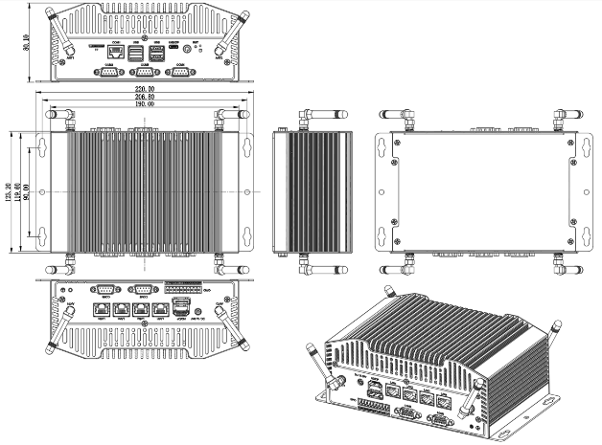

Ordering Information
Model | Optional items | Description
N-BOX-S7 | CPU optional​ | Alder Lake-N series processor
N-BOX-S7 | External TPM2.0 | External TPM2.0 optional
N-BOX-S7 | POE optional | LAN1/2/3/4 optional POE
N-BOX-S7 | COM1/2/3/4/5 optional | COM1/2/3/4/5 optional RS232/RS485, through hardware material selection

