N-BOX-T5

◆ Integrated Intel Gemini Lake single CPU；
◆ Support TPM2.0(optional)
◆Provide 1*VGA,1*HDMI 1.4（Support 4K display output）；
◆COM1,2 can be selected as RS232 or RS485 by jumper and BIOS settings, COM3, COM4, COM5, COM6 are RS232
◆ onboard 32/64/128G EMMC storge chipset（optional）;
◆ Support power-on automatic boot function, jump selection；
◆ Wide viltage 12-19V power supply；
◆ Size 134*126*46.8 mm

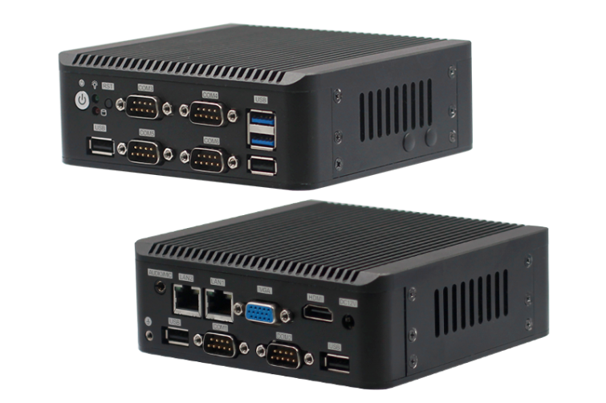

Specification
Processor system | CPU | Integrated Intel Gemini Lake single CPU
Processor system | CPU package | BGA
Processor system | Chipset | Intel Gemini Lake serial SOC
Processor system | BIOS | EFI BIOS
Memory | Technology framework | Single channel DDR4 2133Mhz
Memory | Memory | MAX Support DDR4 8G
Memory | Socket | DDR4 SODIMM 60 Socket
Video | Graphic controller | Intel UHD 600 Graphics
Video | HDMI | HDMI（2.0）MAX resolution 4K@60Hz
Video | VGA | VGA MAX resolution 1920x1200
I/O rear panel | ports | 1*HDMI 2*USB3.0 4*USB2.0 2*LAN 6*COM(COM1,2 can be selected as RS232 or RS485 by jumper and BIOS settings，RS485 supports automatic flow control，COM3,COM4,COM5,COM6 are RS232) 1*Quick boot button with indicator light 1*Reset button 1*DC 1*Power indicator light 1*Hard disk indicator light
Network | Controller | 2*Intel I211AT or Intel I210High-performance gigabit network card(Optional)
Input/output interface | USB | 4*USB2.0 2*USB3.0 Max support +5V/1A
Input/output interface | Com port | COM1,2 can be selected as RS232 or RS485 by jumper and BIOS settings，RS485 supports automatic flow control，COM3,COM4,COM5,COM6 are RS232
Expansion bus | Mini-PCle | 1 Mini-PCIe socket,support PCIe and USB device（5G module or 4G module optional）
Storge | SATA | 1 standard SATAIII interface with a maximum transfer rate of 6Gb/s
Storge | M-SATA | 1*Mini-PCIe M-SATA Scoket,Support SANDISK protocol, maximum transfer rate of 6gb/s
Storge | EMMC | Support 32/64/128G(optional）
Power supply | Power Type | Single input dc power supply,DC12-19V
Working environment | Operating temperature | -20℃ ~ +60℃
Working environment | Storage temperature | -40℃ ~ +85℃
Working environment | Working humidity | 0% ~ 90% relative humidity, no condensation
Working environment | Storage humidity | 0% ~ 90% relative humidity, no condensation
System Support |  | Windows10 Linux
Physical dimension | Size | 134*126*46.8 mm
Physical dimension | Weight | 0.5KG
Certification |  | CE,ROHS,FCC

N-BOX-T5

Size
单位：mm
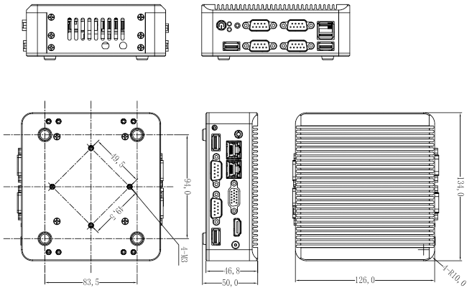

Order Info
Item NO. | Spec | CPU optional
GN41NA | Integrated Intel Gemini Lake single chip CPU | J4105/J4005/N4100

